

Configuration of CICD for ACD Autorenewal Service

**ACD5**

Document Revision History

**Document Revision History**

|  |  |  |  |  |  |
| --- | --- | --- | --- | --- | --- |
| Version | Date | Description | Author | Reviewed By | Approved By |
| 1.0 | 21st July 2022 | Configuration of CICD for ACD Autorenewal Service | Abhijeet Gaikwad | Dhanraj L. Garima V. |  |
|  |  |  |  |  |  |
|  |  |  |  |  |  |
|  |  |  |  |  |  |
|  |  |  |  |  |  |
|  |  |  |  |  |  |

Table of Content

1 Introduction 4

2 Pre-requisites 4

2.1 Hardware Details: 4

2.2 Software Details: 4

2.3 DevOps Details: 4

2.4 Deployed Servers Details: 4

3 Installation of ASP.Net Core 6.0.5 Hosting Bundle: 4

3.1 Download Details: 4

3.2 Installation Process: 5

4 Initial Manual Setup of Autorenewal Service: 6

4.1 Creation of folder for manual Deployment: 6

4.2 Creating a Logs Directory for Autorenewal Service: 6

4.3 Creating a windows service for Autorenewal: 6

5 DevOps Configuration - CI for Service. 7

5.1 Setup CI for AutoRenewal Service: 7

6 Configuration CD for Autorenewal Service. 12

6.1 Creating CD for AutoRenewal Service: 12

6.2 Adding variables to CD for AutoRenewal Service: 20

7 References. 21

1. Introduction

The purpose of this document is to determine all the requirements configuring CICD for Autorenewal Service on Non-Prod (TEST & QA) & Production Environment in Windows Server 2019 Datacenter Version**.**

1. Pre-requisites

## Hardware Details:

Below is the VM configuration used for Non-Prod (Test & QA) environment:

* Operation System: Windows Server 2019 Datacenter
* Memory: 8 GB
* Processor: Processor AMD EPYC 7452 32-Core Processor (2vcpu)
* HDD: OS Disk(128GB) & Data Disk (128 GB)

Below is the VM configuration used for Production Environment:

* Operation System: Windows Server 2019 Datacenter
* Memory: 8 GB
* Processor: Processor AMD EPYC 7452 32-Core Processor (2vcpu)
* HDD: OS Disk(128GB) & Data Disk (128 GB)

## Software Details:

Below are the required applications for configuration of Autorenewal Service:

* Operation System: Windows Server 2019 Datacenter
* Feature: Microsoft .Net 6.0 Windows Server Hosting

## DevOps Details:

* Repository – ACD.AutoRenewalService
* Url:https://dev.azure.com/aiaacd/ACDOnlineService/_git/ACD.AutoRenewalService

## Service Deployment Details:

The Autorenewal Service will be deployed on all APP Servers in Test, QA & Production environment but it will only be running on one server in each environment.

Service will be running on below servers:

* Test Environment: vmTestApp02 (IP: 10.0.0.6)
* QA Environment: vmQAApp02 (IP: 10.0.4.13)
* Prod Environment: vmprodapp02 (IP: 172.16.192.21)

1. Installation of ASP.Net Core 6.0.5 Hosting Bundle:

## Download Details:

Download the latest version of ASP.Net Core 6.0 from Microsoft official Link:

<https://dotnet.microsoft.com/en-us/download/dotnet/6.0>

## Installation Process:

Double Click the downloaded file and it will popup the installation Wizard as below:

Click on Install option the installation process will start and once its completed close the pop-up screen.

1. Initial Manual Setup of Autorenewal Service:

## Creation of folder for manual Deployment:

Creating folder for service in specific location “F:\WServices” on both Non-Prod & prod VM.

* Graphical user interface, text, application

  Description automatically generatedACDAutoRenewalService – “F:\WServices\ACDAutoRenewalService”
* Copying the code for initially testing of service.

*Note: For initial state we are manually deploying the code to the above path to setup the service which will be auto deployed by CICD later.*

## Creating a Logs Directory for Autorenewal Service:

Creating folders for Service logs in below location:

* *F:\Logs\ACD\ACDAutoRenewalService*

## Creating a windows service for Autorenewal:

Open **powershell** as an administrator and execute below script.

**$params = @{**

**Name = "ACD.AutoRenewalService"**

**BinaryPathName = "F:\WServices\ACDAutoRenewalService\ACD.AutoRenewalService.exe"**

**DependsOn = "NetLogon"**

**DisplayName = "ACD AutoRenewal Service"**

**StartupType = "Automatic"**

**Description = "This is a ACD Autorenewal Service."**

**}**

**New-Service @params**

**Start-Service "ACD.AutoRenewalService"**

**Write-Host "service started successfully"**

The above script will create and start the service.

1. DevOps Configuration - CI for Service.

## Setup CI for AutoRenewal Service:

* Graphical user interface, application

  Description automatically generatedLogin to devops using the url <https://dev.azure.com/aiaacd/> and go to ACDOnlineServices as shown below:
* Graphical user interface, text, application, email

  Description automatically generatedIn ACDOnlineService, navigate to Pipelines > **New Pipeline**
* Start creating the pipeline using classic editor.

* 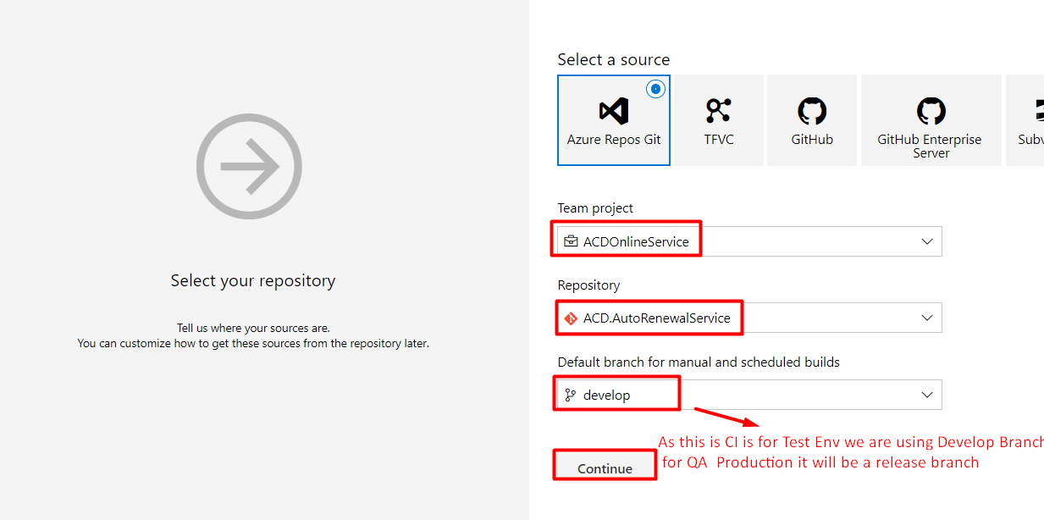By clicking on classic editor, it will pop-up new window, select the options as per below image.

Select Source – **Azure Repos git**

Team Project – **ACDOnlineService**

Repository – **ACD.AutoRenewalService**

Default branch for manual and scheduled builds – **develop**

* Click continue to proceed ahead, next step is to choose existing template.
* Graphical user interface, application

  Description automatically generatedSelect ASP.NET Core from the list and click on Apply Button.
* After applying the template, it will ask for further settings as below
* Click on Pipeline and change pipeline name and agent pool from the dropdown.

Name: acd-autorenewalservice-prod-ci

Agent pool: dev-acdpool

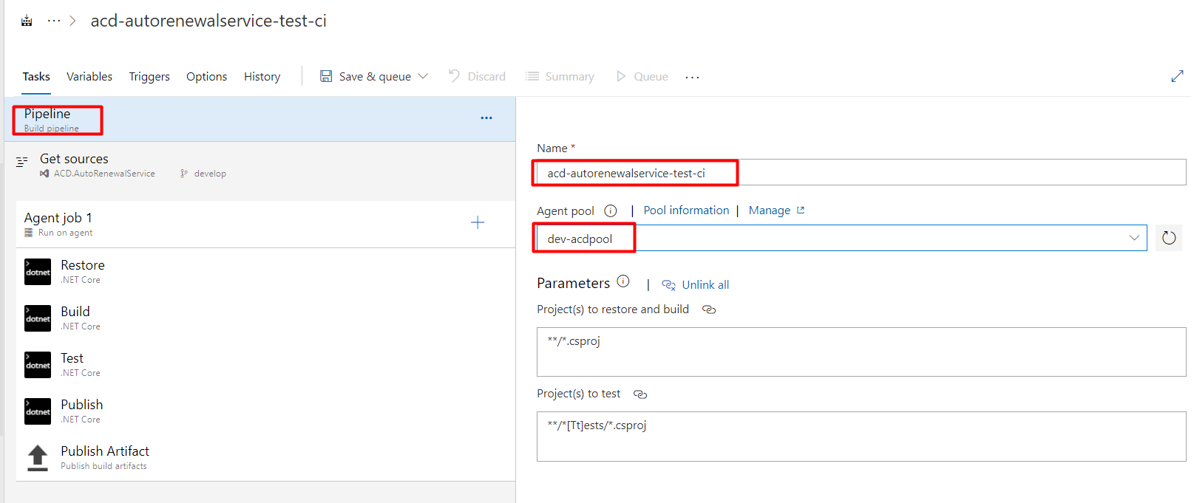Keep all other settings as default.

* Next click on Restore stage and set packages as **ACD** from dropdown, keep other settings as default.

* Next step is for adding SDK task before Restore task. By clicking the Plus ‘+’ sign.
* Graphical user interface, application, Word

  Description automatically generatedAdd task to use .net core sdk as shown in below image and drag the step to the top before restore step.
* Edit the SDK task and add the sdk version and click on save button.
* 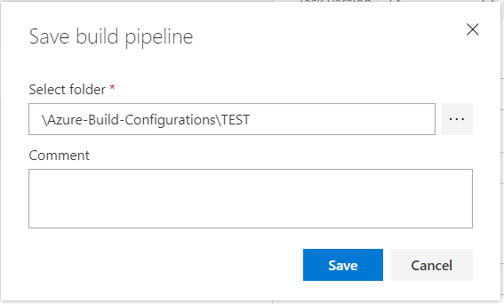While saving the changes it will ask for the folder path set as shown below:

Test CI Path: “*\Azure-Build-Configurations\TEST”*  
 QA CI Path: “*\Azure-Build-Configurations\QA”*

Prod CI Path: “*\Azure-Build-Configurations\PROD”*

* Once Pipeline is saved, navigate to pipelines > ALL > Azure-Build-Configurations > TEST > acd-autorenewalservice-test-ci
* 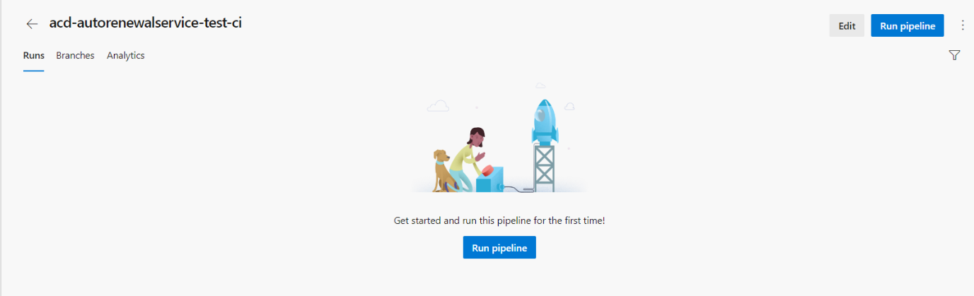Click on Run pipeline button to start the execution of Pipeline.
* 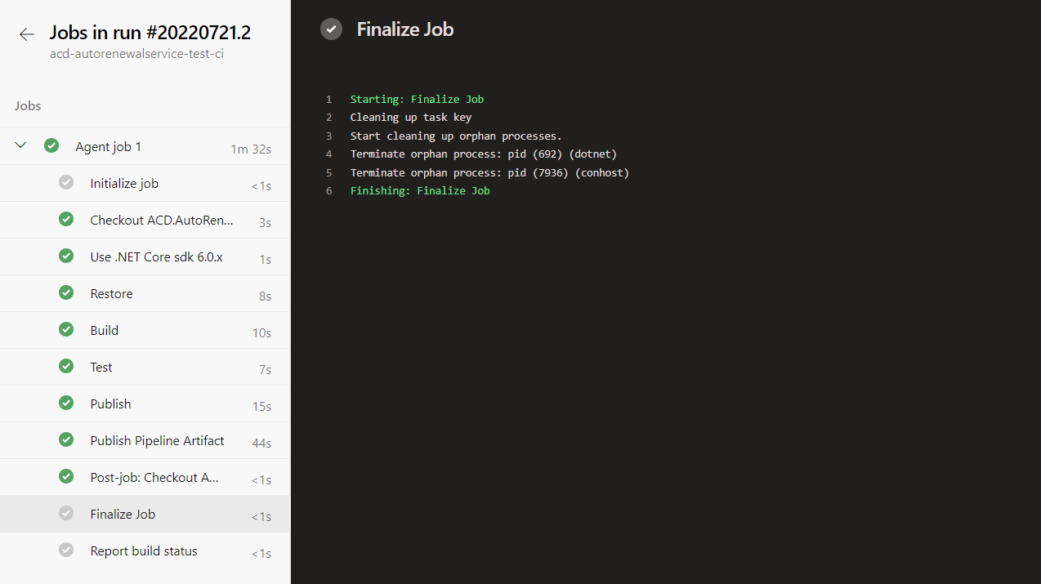This will start the execution of pipeline. Next got to the agent job and it will process all the steps and show the results as below:

1. Configuration CD for Autorenewal Service.

## Creating CD for AutoRenewal Service:

* In ACDOnlineService, navigate to Pipelines > Release > New > New release pipeline.
* Graphical user interface, application, Teams

  Description automatically generatedThis will ask you for selecting a template, select Empty Job.
* Input the stage name and save the stage.

Stage Name for Environment:

For Test – TEST

For QA – QA

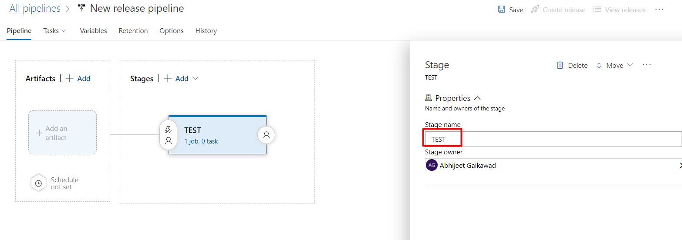 For Production – PROD

Initially we need to add an artifact for the pipeline, click on add Arrtifacts option:

* 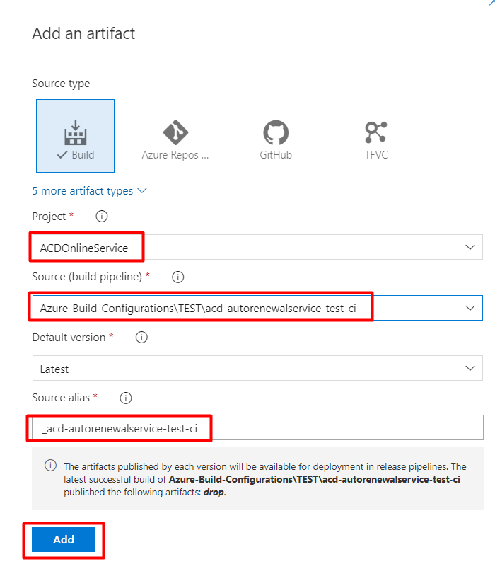PowerPoint

  Description automatically generatedSelect the artificats from the dropdown as shown below:
* Next Step is to add Deployment Group Job.
* Click on **1 job, 0 task** and remove the default agent job and add two Deployment Jobs as below.

1. AutoRenewal Service AppServer01 – This will deploy the code on APPServer01 on Test Environment, but it just keeps the copy of service it will not start the service.
2. AutoRenewal Service AppServer02 – This will deploy the code on APPServer02 on Test Environment and start the service.

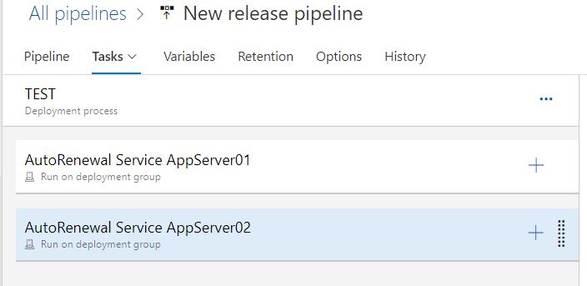

* Graphical user interface, text, application, email

  Description automatically generatedBelow are the configurations for AutoRenewal Service AppServer01**.**
* 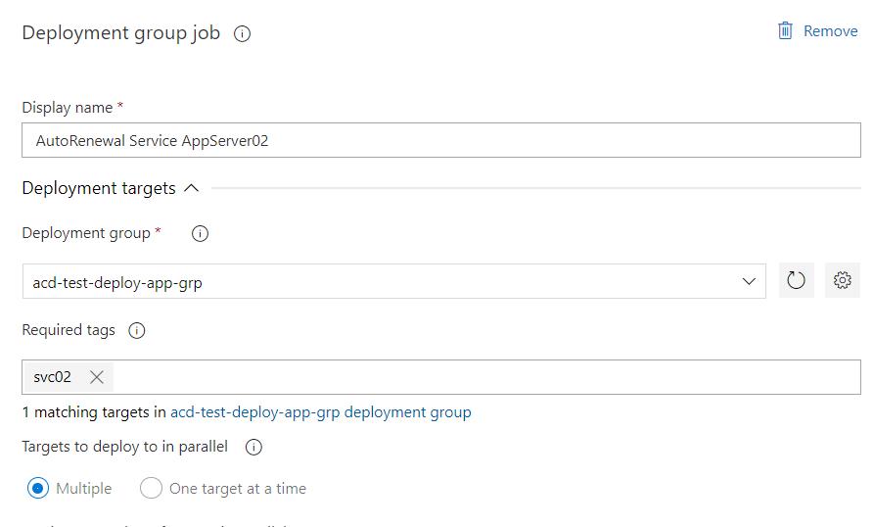And for AutoRenewal Service AppServer02
* Once the Deployment Group are created, we can start creating task within the deployment groups.

**For Deployment Group - AutoRenewal Service AppServer01**

Task01 – PowerShell Script.

Paste the below script in textbox:

**$arrService= "ACD.HubSpotSyncService"**

**$arrService = Get-Service -Name $arrService**

**write-host $arrService**

**while($arrService.Status -eq 'Running')**

**{ Stop-Service $arrService**

**write-host $arrService.status**

**write-host 'Service stopping'**

**Start-Sleep -seconds 15**

**$arrService.Refresh()**

**if ($arrService.Status -eq 'Stopped')**

**{**

**Write-Host 'Service is now Stopped'**

**}**

**}**

**if ($arrService.Status -eq 'Stopped')**

**{**

**sc.exe delete $arrService**

**Write-Host 'Service is now deleted'**

**}**

* Keep all other below settings as default.

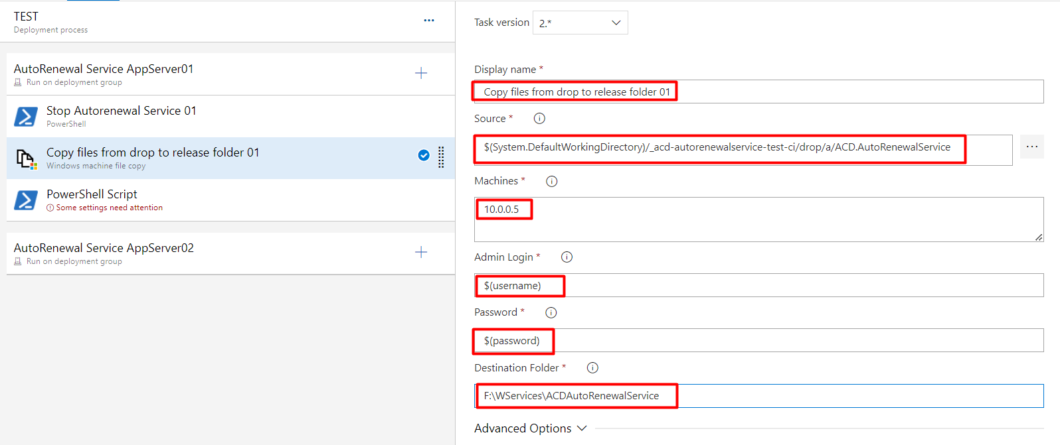Task02 – Copy Files from

Task03 – Powershell Script

Paste the below script in textbox:

**$params = @{**

**Name = "ACD.AutoRenewalService"**

**BinaryPathName = "F:\WServices\ACDAutoRenewalService\ACD.AutoRenewalService.exe"**

**DependsOn = "NetLogon"**

**DisplayName = "ACD AutoRenewal Service"**

**StartupType = "Disabled"**

**Description = "This is a ACD Autorenewal Service."**

**}**

**New-Service @params**

**Write-Host 'Service is now deployed and disabled'**

* Keep all other below settings as default.

**For Deployment Group - AutoRenewal Service AppServer02**

Task01 – PowerShell Script.

Paste the below script in textbox:

**$arrService= "ACD.HubSpotSyncService"**

**$arrService = Get-Service -Name $arrService**

**write-host $arrService**

**while($arrService.Status -eq 'Running')**

**{ Stop-Service $arrService**

**write-host $arrService.status**

**write-host 'Service stopping'**

**Start-Sleep -seconds 15**

**$arrService.Refresh()**

**if ($arrService.Status -eq 'Stopped')**

**{**

**Write-Host 'Service is now Stopped'**

**}**

**}**

**if ($arrService.Status -eq 'Stopped')**

**{**

**sc.exe delete $arrService**

**Write-Host 'Service is now deleted'**

**}**

* Keep all other below settings as default.

Task02 – Copy Files from

Task03 – Powershell Script

Paste the below script in textbox:

**$params = @{**

**Name = "ACD.AutoRenewalService"**

**BinaryPathName = "F:\WServices\ACDAutoRenewalService\ACD.AutoRenewalService.exe"**

**DependsOn = "NetLogon"**

**DisplayName = "ACD AutoRenewal Service"**

**StartupType = "Automatic"**

**Description = "This is a ACD Autorenewal Service."**

**}**

**New-Service @params**

**Start-Service "ACD.AutoRenewalService"**

**Write-Host "service started successfully"**

* Keep all other below settings as default
* Now the CD Pipeline is ready to save, you need to rename and save the pipeline to specific location.

Test CI Path: *“\Azure-Release-Configurations\ACD_TestCD”*  
QA CI Path: “*\Azure-Release-Configurations\ACD_QACD”*

Prod CI Path: “*\Azure-Release-Configurations\ACD_* *PRODCD”*

## Adding variables to CD for AutoRenewal Service:

* 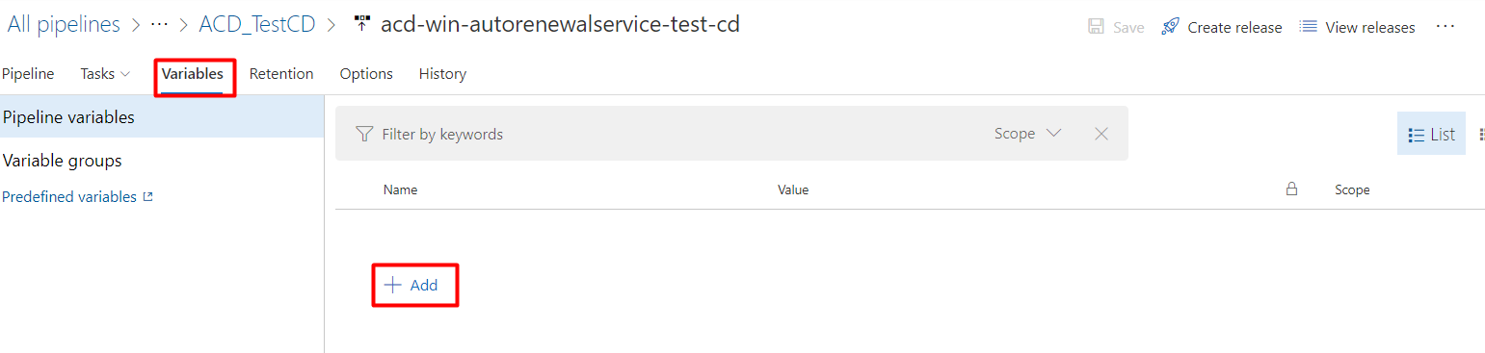Navigate to Pipeline >> Variables tab & add the username and password as shown in below image.

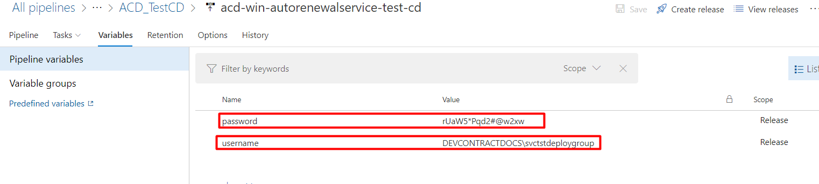

Using similar steps CICD for Production will be setup.

1. References.

* [Quickstart: Create a CI/CD pipeline for .NET with Azure DevOps Starter | Microsoft Docs](https://docs.microsoft.com/en-us/azure/devops-project/azure-devops-project-aspnet-core)